

**TRIGGER EXAM**

**SNAPSHOTS**

* **Admin Dashboard**

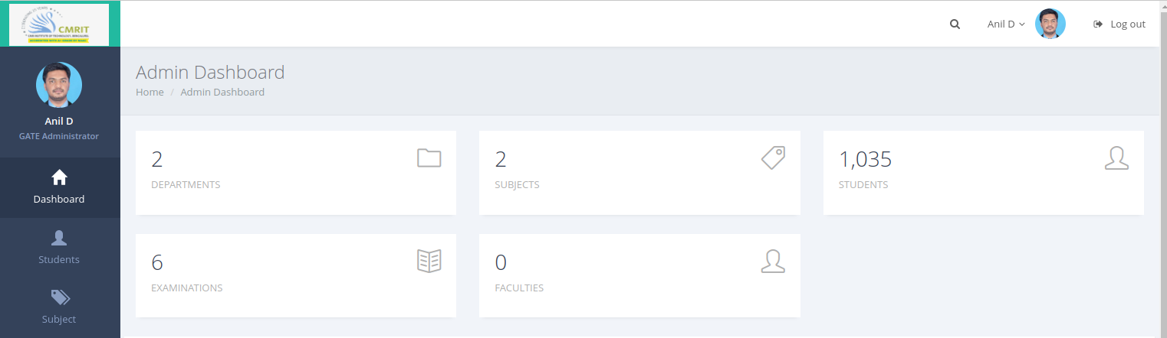

* **Registering Student Data**

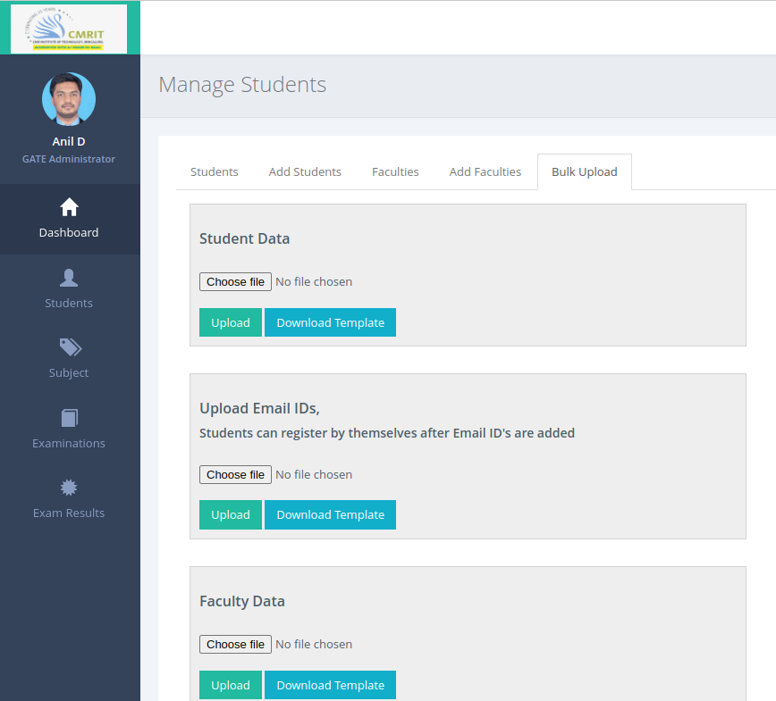

* **Excel Template to add students**

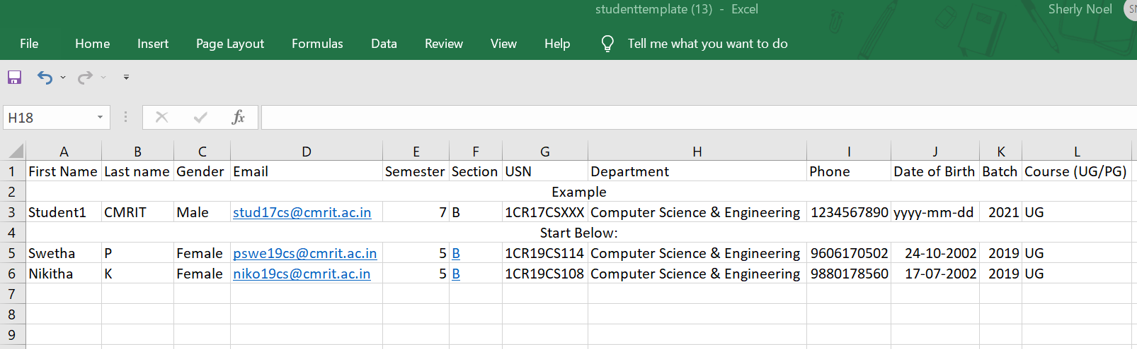

* **Question Bank Creation**

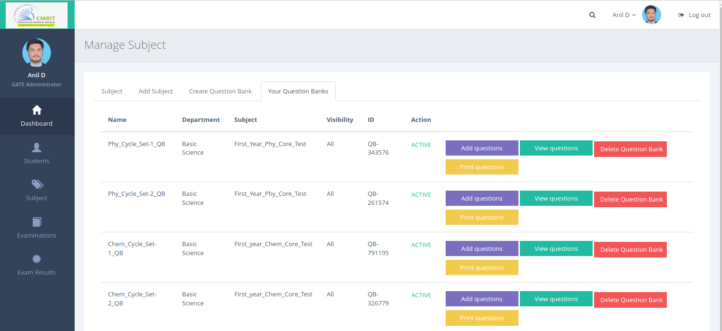

* **Exam Creation**

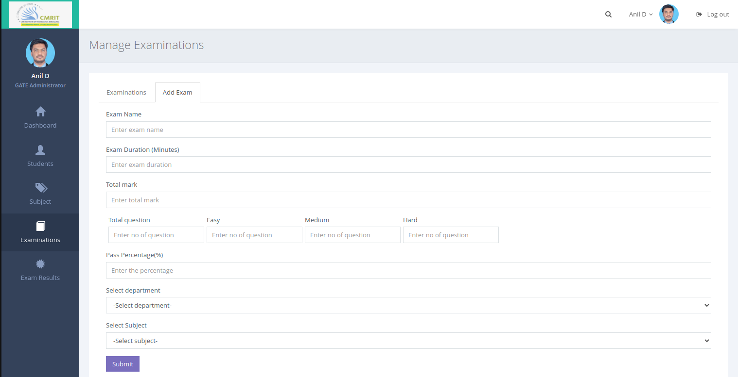

* **Manage Exam**

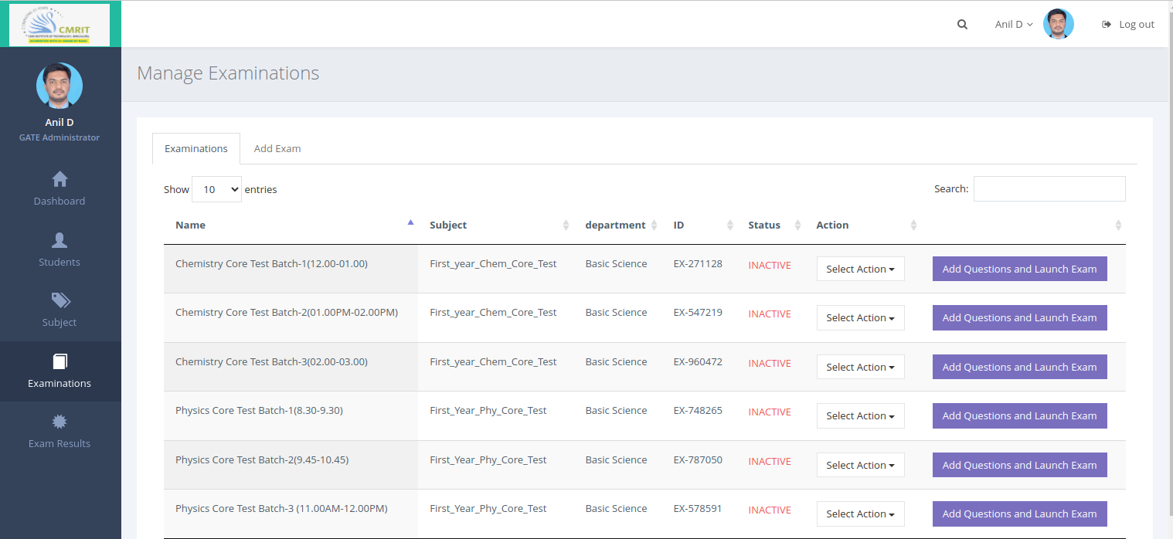

* **View Questions**

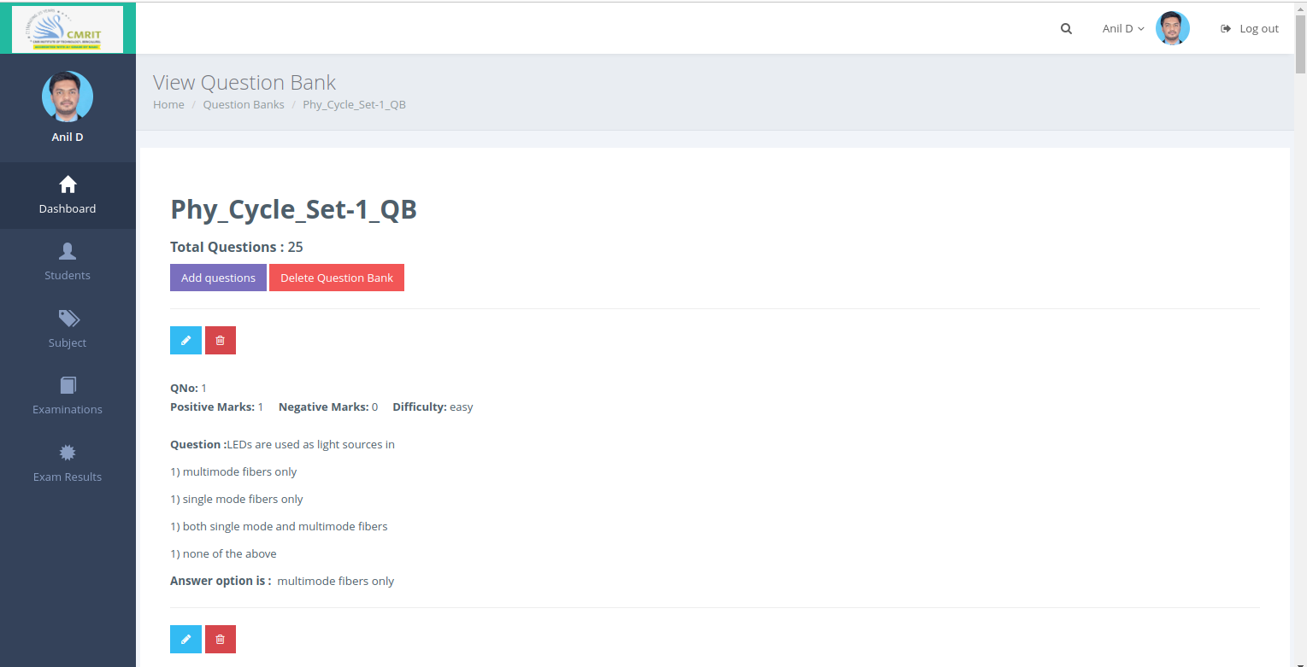

* **Exam Results**

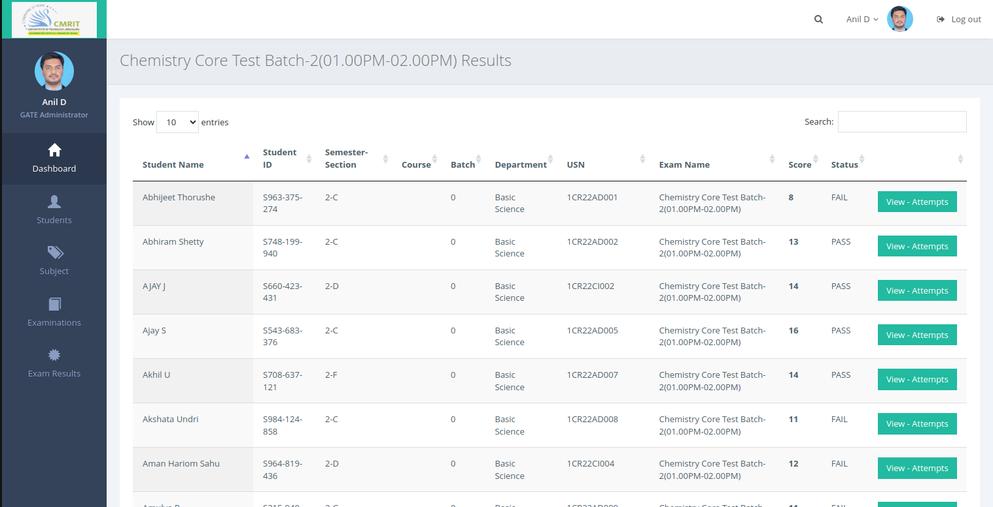

* **Students Dashboard**

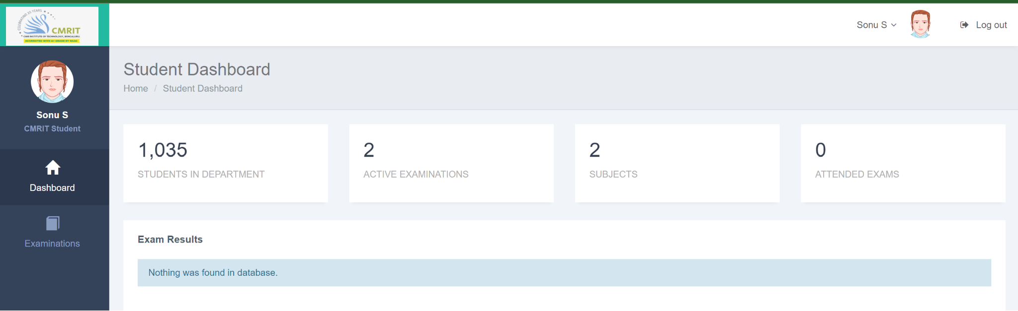

* **Question Palette**

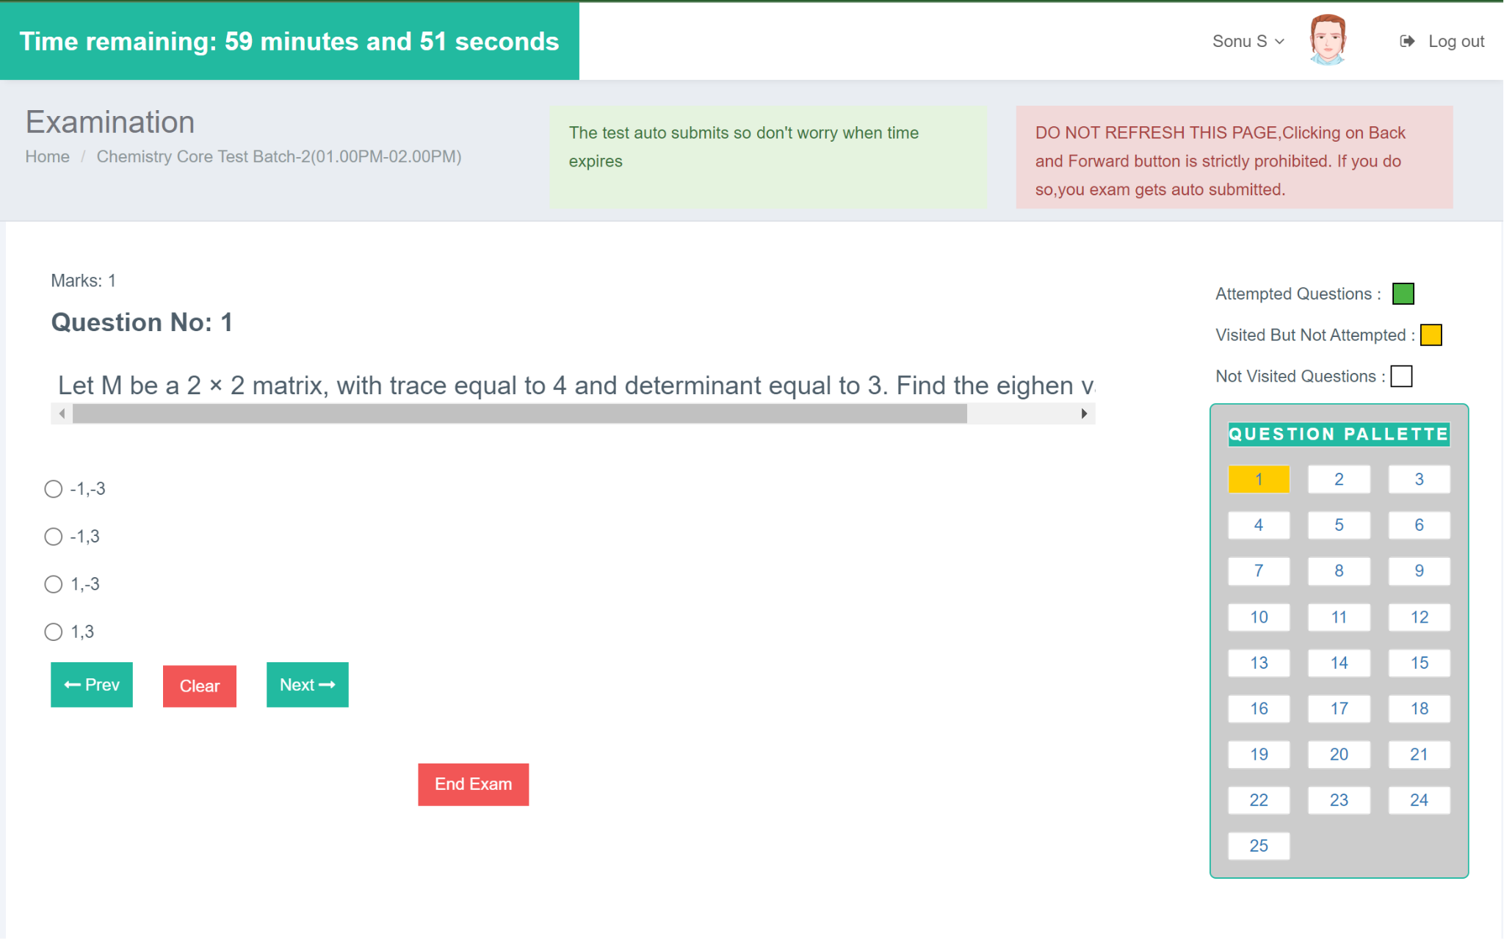

* **Switching Tab Alerts**

